Lab 6.3: Mongodb aggregration Framework
Date: 02/12/2025
Objectives:
1. Understand the MongoDB Aggregation Framework
2. Implement aggregation operators: $sum, $avg, $count, $last
3. Perform grouping, filtering, and sorting using aggregation pipelines

1: SETUP DATABASE AND COLLECTION

- Switch to database
use OIC
- Remove existing collection (if any)
db.sales.drop()
- Create collection
db.createCollection("sales")
- Insert sample sales data
db.sales.insertMany([
{ _id: 1, item: "Americanos", price: 5, size: "Short", quantity: 22, date: ISODate("2022-01-15T08:00:00Z") },
{ _id: 2, item: "Cappuccino", price: 6, size: "Short", quantity: 12, date: ISODate("2022-01-16T09:00:00Z") },
{ _id: 3, item: "Lattes", price: 15, size: "Grande", quantity: 25, date: ISODate("2022-01-16T09:05:00Z") },
{ _id: 4, item: "Mochas", price: 25, size: "Tall", quantity: 11, date: ISODate("2022-02-17T08:00:00Z") },
{ _id: 5, item: "Americanos", price: 10, size: "Grande", quantity: 12, date: ISODate("2022-02-18T21:06:00Z") },
{ _id: 6, item: "Cappuccino", price: 7, size: "Tall", quantity: 20, date: ISODate("2022-02-20T10:07:00Z") },
{ _id: 7, item: "Lattes", price: 25, size: "Tall", quantity: 30, date: ISODate("2022-02-21T10:08:00Z") },
{ _id: 8, item: "Americanos", price: 10, size: "Grande", quantity: 21, date: ISODate("2022-02-22T14:09:00Z") },
{ _id: 9, item: "Cappuccino", price: 10, size: "Grande", quantity: 17, date: ISODate("2022-02-23T14:09:00Z") },
{ _id: 10,item: "Americanos", price: 8, size: "Tall", quantity: 15, date: ISODate("2022-02-25T14:09:00Z") }
])
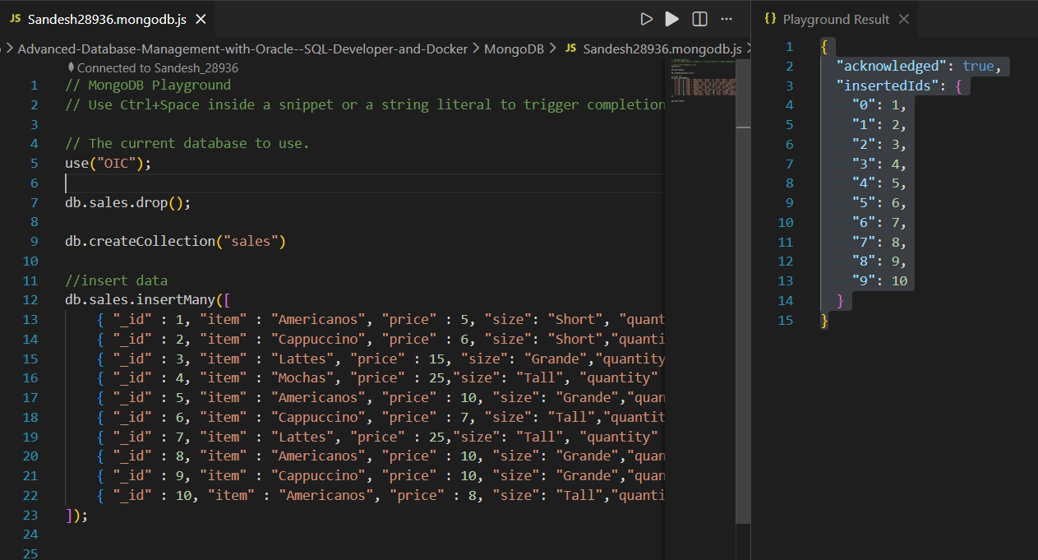
- Verify:
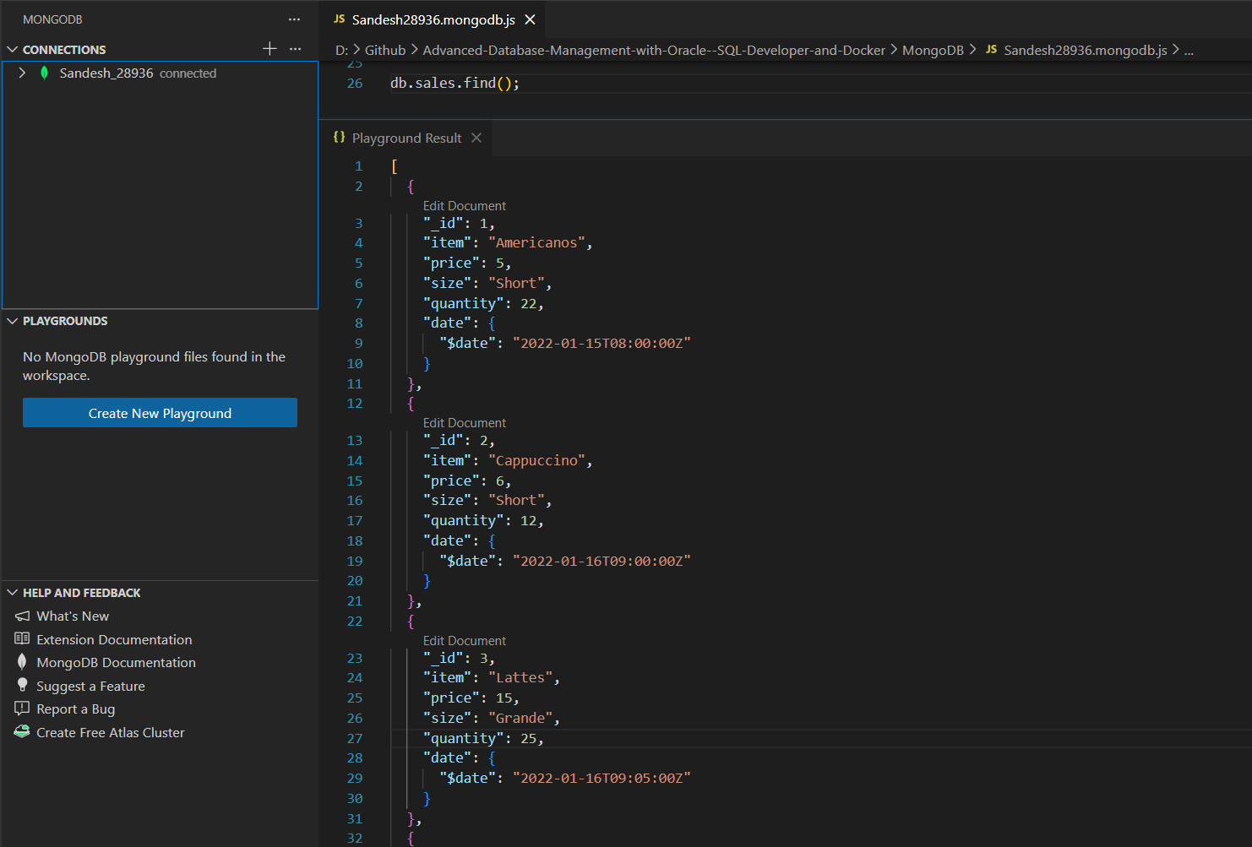

2: AGGREGATION USING $MATCH, $GROUP, $SUM

- Total quantity of Americanos sold grouped by size
db.sales.aggregate([
{ $match: { item: "Americanos" } },
{
$group: {
_id: "$size",
totalQuantity: { $sum: "$quantity" }
}
},
{ $sort: { totalQuantity: -1 } }
])
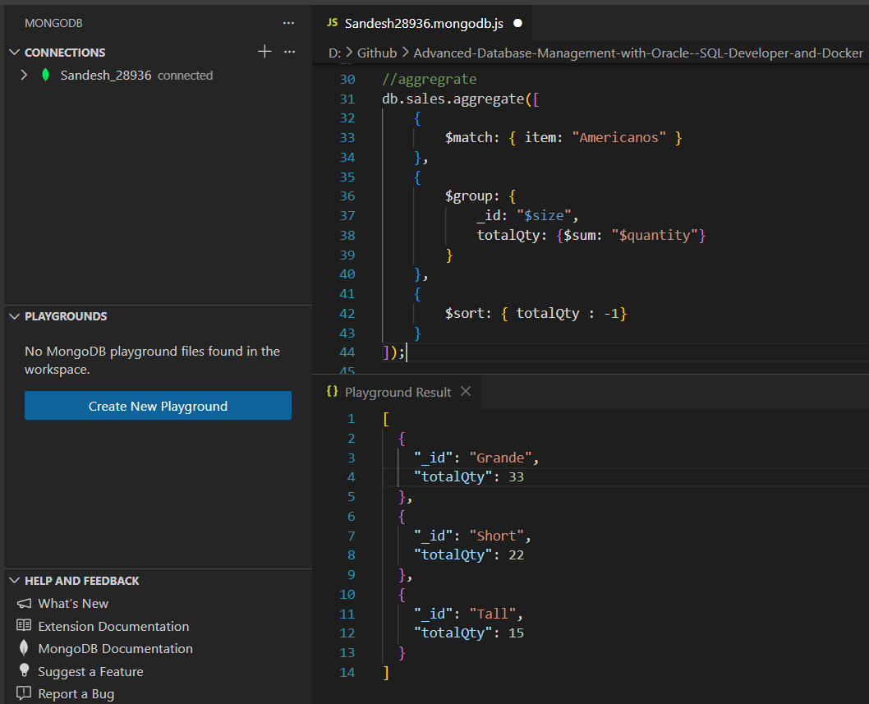

3: AGGREGATION USING $SUM AND $COUNT

- Total quantity sold across all items
db.sales.aggregate([
{
$group: {
_id: null,
totalQuantitySold: { $sum: "$quantity" }
}
}
])
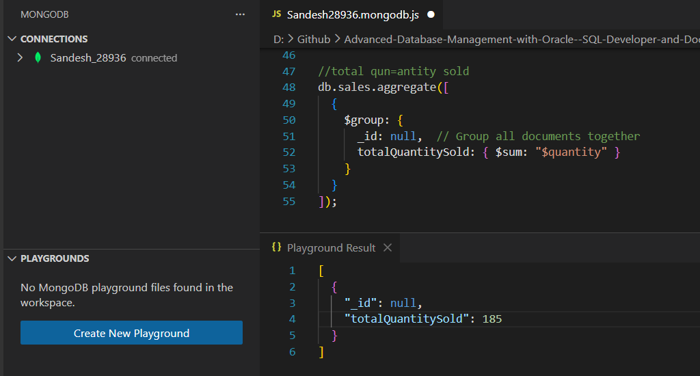

CONCLUSION
The MongoDB Aggregation Framework was successfully used to
analyze sales data. Operators such as $sum, $avg, $count,
and $last enabled meaningful data aggregation, grouping,
and sorting. This demonstrates MongoDB’s capability to
perform complex analytics directly within the database.

